*. Jira. Задача "Прогнать скрипты по серверам для аудита PCI DSS" (https://jira.tcsbank.ru/browse/IN-1795) [Kryukov Anton][назначил Александров Алексей].

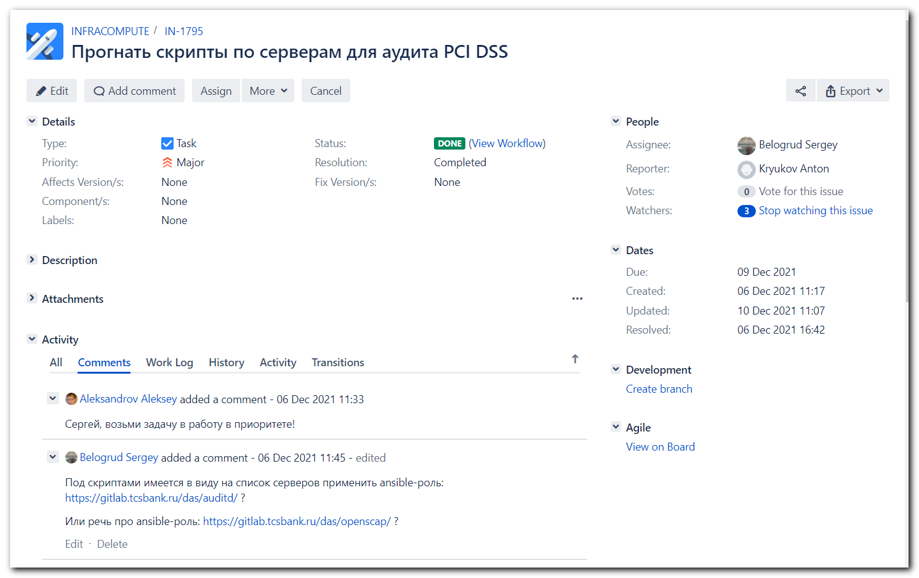
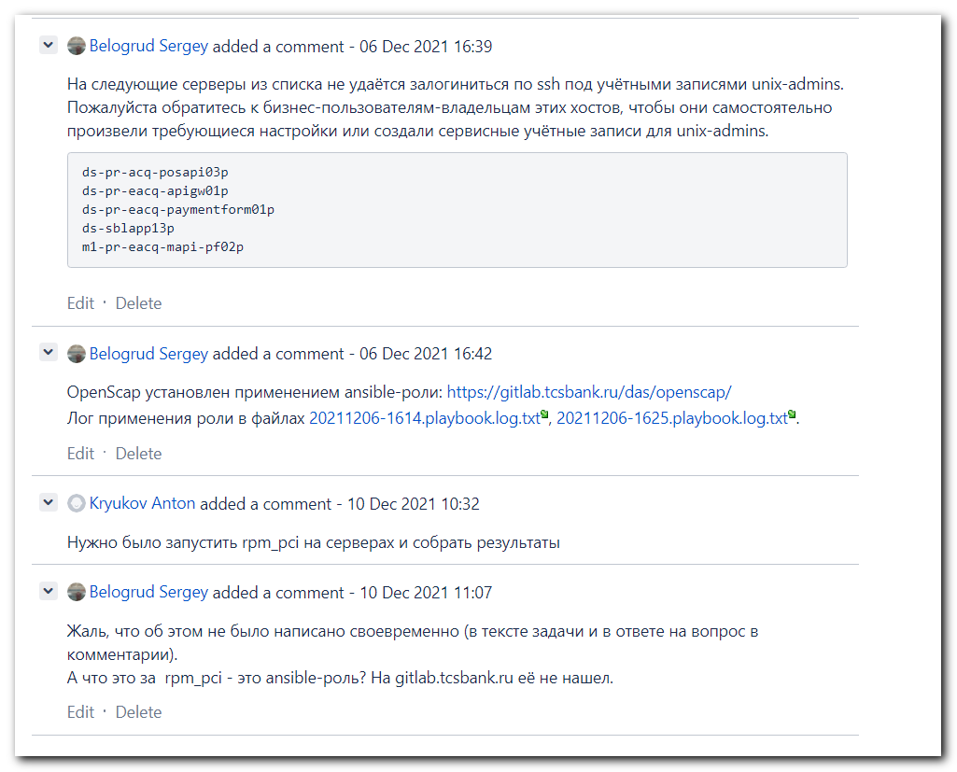

[s.belogrud@nb2339]# vim /drives/c/data/share/20211210-1118.rpm_pci.sh

[support@nb2339]# SSHPASS="$(pass common/linux-unix-ansible)" sshpass -e scp -oStrictHostKeyChecking=no -oPubkeyAuthentication=no -oUserKnownHostsFile=/dev/null /mnt/c/data/share/20211210-1118.rpm_pci.sh unix-ansible@m1-pr-prime-info-atm-02:/tmp/
Warning: Permanently added 'm1-pr-prime-info-atm-02,10.212.10.23' (ECDSA) to the list of known hosts.
[support@nb2339]#

[s.belogrud@nb2339]# ssh s_s.belogrud@m1-pr-prime-info-atm-02
Warning: Permanently added 'm1-pr-prime-info-atm-02' (RSA) to the list of known hosts.
Creating directory '/home/idm/s_s.belogrud'.
s_s.belogrud@m1-pr-prime-info-atm-02 ~$ sudo -i

We trust you have received the usual lecture from the local System
Administrator. It usually boils down to these three things:

#1) Respect the privacy of others.
#2) Think before you type.
#3) With great power comes great responsibility.

[sudo] password for s_s.belogrud:
root@m1-pr-prime-info-atm-02 ~$ ls /tmp/20211210-1118.rpm_pci.sh
/tmp/20211210-1118.rpm_pci.sh
root@m1-pr-prime-info-atm-02 ~$

[support@nb2339]# list_of_hosts="" ; while read var1_hosts ; do list_of_hosts="${list_of_hosts} ${var1_hosts}" ; done << 'EOF' ; for var1_hosts in ${list_of_hosts} ; do SSHPASS="$(pass common/linux-freeipa)" sshpass -e timeout 30 ssh -t -oStrictHostKeyChecking=no -oPubkeyAuthentication=no s_s.belogrud@${var1_hosts}.tcsbank.ru "( echo '$(pass common/linux-freeipa)' | sudo -S -i sh -c 'echo ; hostname ; ls /tmp/20211210-1118.rpm_pci.sh' )" ; done
> m1-pr-prime-info-atm-02
> EOF
Warning: Permanently added 'm1-pr-prime-info-atm-02.tcsbank.ru' (ECDSA) to the list of known hosts.
[sudo] password for s_s.belogrud:
m1-pr-prime-info-atm-02.tcsbank.ru
/tmp/20211210-1118.rpm_pci.sh
Connection to m1-pr-prime-info-atm-02.tcsbank.ru closed.
[support@nb2339]#

# Manual start.
root@m1-pr-prime-info-atm-02 ~$ /bin/bash /tmp/20211210-1118.rpm_pci.sh
cat: /etc/modprobe.d/blacklist.conf: No such file or directory
cat: /etc/modprobe.conf: No such file or directory
cat: /etc/ldap/ldap.conf: No such file or directory
cat: /etc/sssd.conf: No such file or directory

Note: This output shows SysV services only and does not include native
systemd services. SysV configuration data might be overridden by native
systemd configuration.

If you want to list systemd services use 'systemctl list-unit-files'.
To see services enabled on particular target use
'systemctl list-dependencies [target]'.

cat: /etc/syslog.conf: No such file or directory
cat: /etc/sysctl.d/98-sysctl.conf: No such file or directory
root@m1-pr-prime-info-atm-02 ~$

root@m1-pr-prime-info-atm-02 ~$ ls /tmp/m1-pr-prime-info-atm-02.tcsbank.ru.2021.txt
/tmp/m1-pr-prime-info-atm-02.tcsbank.ru.2021.txt
root@m1-pr-prime-info-atm-02 ~$ head /tmp/m1-pr-prime-info-atm-02.tcsbank.ru.2021.txt
======= common ==========
uname
Linux m1-pr-prime-info-atm-02.tcsbank.ru 3.10.0-1127.19.1.el7.x86_64 #1 SMP Tue Aug 25 17:23:54 UTC 2020 x86_64 x86_64 x86_64 GNU/Linux
release
CentOS Linux release 7.8.2003 (Core)
fstab

#
# /etc/fstab
# Created by anaconda on Wed Jun 10 01:33:38 2020
root@m1-pr-prime-info-atm-02 ~$

[support@nb2339]# list_of_hosts="" ; while read var1_hosts ; do list_of_hosts="${list_of_hosts} ${var1_hosts}" ; done << 'EOF' ; for var1_hosts in ${list_of_hosts} ; do SSHPASS="$(pass common/linux-freeipa)" sshpass -e timeout 30 ssh -t -oStrictHostKeyChecking=no -oPubkeyAuthentication=no s_s.belogrud@${var1_hosts}.tcsbank.ru "( echo '$(pass common/linux-freeipa)' | sudo -S -i sh -c 'echo ; hostname ; ls /tmp/20211210-1118.rpm_pci.sh ; /bin/bash /tmp/20211210-1118.rpm_pci.sh' )" ; done
> m1-pr-prime-info-atm-02
> EOF
[sudo] password for s_s.belogrud:
m1-pr-prime-info-atm-02.tcsbank.ru
/tmp/20211210-1118.rpm_pci.sh
cat: /etc/modprobe.d/blacklist.conf: No such file or directory
cat: /etc/modprobe.conf: No such file or directory
cat: /etc/ldap/ldap.conf: No such file or directory
cat: /etc/sssd.conf: No such file or directory

Note: This output shows SysV services only and does not include native
systemd services. SysV configuration data might be overridden by native
systemd configuration.

If you want to list systemd services use 'systemctl list-unit-files'.
To see services enabled on particular target use
'systemctl list-dependencies [target]'.

cat: /etc/syslog.conf: No such file or directory
cat: /etc/sysctl.d/98-sysctl.conf: No such file or directory
Connection to m1-pr-prime-info-atm-02.tcsbank.ru closed.
[support@nb2339]#

# Here are 20 hosts on whitch I can login.

m1-pr-prime-info-atm-02
m1-pr-k8s-worker-1
m1-pr-k8s-master-3
ds-pr-paym-static-01p
ds-pr-pg-qr01p
m1-pr-ops07
ds-prt-prod-api64
ds-prt-prod-api115
ds-pr-pg12p
ds-pr-onlacq01
ds-db41-prod1
m1-db21-dr
ds-pr-ipsilon02
vm-pr-pg-ui01
vm-pr-pgdb01
ds-atm-kaba-vpn01p
vd-pr-prime-ppmb01
vm-infrasecapi03p
vm-pr-jenkins01
ds-pr-paym-kafka02p

list_of_hosts="" ; while read var1_hosts ; do list_of_hosts="${list_of_hosts} ${var1_hosts}" ; done << 'EOF' ; for var1_hosts in ${list_of_hosts} ; do SSHPASS="$(pass common/linux-unix-ansible)" sshpass -e scp -oStrictHostKeyChecking=no -oPubkeyAuthentication=no -oUserKnownHostsFile=/dev/null /mnt/c/data/share/20211210-1118.rpm_pci.sh unix-ansible@${var1_hosts}:/tmp/ ; done

[support@nb2339]# list_of_hosts="" ; while read var1_hosts ; do list_of_hosts="${list_of_hosts} ${var1_hosts}" ; done << 'EOF' ; for var1_hosts in ${list_of_hosts} ; do SSHPASS="$(pass common/linux-unix-ansible)" sshpass -e scp -oStrictHostKeyChecking=no -oPubkeyAuthentication=no -oUserKnownHostsFile=/dev/null /mnt/c/data/share/20211210-1118.rpm_pci.sh unix-ansible@${var1_hosts}:/tmp/ ; done
> m1-pr-prime-info-atm-02
> m1-pr-k8s-worker-1
...
> vm-pr-jenkins01
> ds-pr-paym-kafka02p
> EOF
Warning: Permanently added 'm1-pr-prime-info-atm-02,10.212.10.23' (ECDSA) to the list of known hosts.
Warning: Permanently added 'm1-pr-k8s-worker-1,10.216.78.63' (ECDSA) to the list of known hosts.
Warning: Permanently added 'm1-pr-k8s-master-3,10.216.78.62' (ECDSA) to the list of known hosts.
Warning: Permanently added 'ds-pr-paym-static-01p,10.216.79.53' (ECDSA) to the list of known hosts.
Warning: Permanently added 'ds-pr-pg-qr01p,10.217.11.227' (ECDSA) to the list of known hosts.
Warning: Permanently added 'm1-pr-ops07,10.212.10.182' (ECDSA) to the list of known hosts.
Warning: Permanently added 'ds-prt-prod-api64,10.213.18.104' (ED25519) to the list of known hosts.
Warning: Permanently added 'ds-prt-prod-api115,10.213.192.92' (ECDSA) to the list of known hosts.
Warning: Permanently added 'ds-pr-pg12p,10.213.8.106' (ECDSA) to the list of known hosts.
Warning: Permanently added 'ds-pr-onlacq01,10.217.11.7' (RSA) to the list of known hosts.
Warning: Permanently added 'ds-db41-prod1,10.219.47.144' (ECDSA) to the list of known hosts.
Warning: Permanently added 'm1-db21-dr,10.217.127.82' (ECDSA) to the list of known hosts.
Warning: Permanently added 'ds-pr-ipsilon02,10.219.49.32' (ECDSA) to the list of known hosts.
Warning: Permanently added 'vm-pr-pg-ui01,10.217.12.88' (ECDSA) to the list of known hosts.
Warning: Permanently added 'vm-pr-pgdb01,10.217.12.80' (RSA) to the list of known hosts.
Warning: Permanently added 'ds-atm-kaba-vpn01p,10.219.29.3' (ECDSA) to the list of known hosts.
ssh: connect to host vd-pr-prime-ppmb01 port 22: Resource temporarily unavailable
lost connection
Warning: Permanently added 'vm-infrasecapi03p,10.216.76.11' (ECDSA) to the list of known hosts.
Warning: Permanently added 'vm-pr-jenkins01,10.216.77.1' (ECDSA) to the list of known hosts.
Warning: Permanently added 'ds-pr-paym-kafka02p,10.217.9.18' (ECDSA) to the list of known hosts.
[support@nb2339]#

[s.belogrud@nb2339]# ssh s_s.belogrud@vd-pr-prime-ppmb01
ssh: connect to host vd-pr-prime-ppmb01 port 22: Connection timed out
[s.belogrud@nb2339]#

[support@nb2339]# list_of_hosts="" ; while read var1_hosts ; do list_of_hosts="${list_of_hosts} ${var1_hosts}" ; done << 'EOF' ; for var1_hosts in ${list_of_hosts} ; do SSHPASS="$(pass common/linux-unix-ansible)" sshpass -e timeout 30 ssh -t -oStrictHostKeyChecking=no -oPubkeyAuthentication=no unix-ansible@${var1_hosts}.tcsbank.ru "( echo '$(pass common/linux-unix-ansible)' | sudo -S -i sh -c 'echo ; echo ; hostname ; ls /tmp/20211210-1118.rpm_pci.sh ; /bin/bash /tmp/20211210-1118.rpm_pci.sh' )" ; done
> m1-pr-prime-info-atm-02
> m1-pr-k8s-worker-1
> m1-pr-k8s-master-3
> ds-pr-paym-static-01p
> ds-pr-pg-qr01p
> m1-pr-ops07
> ds-prt-prod-api64
> ds-prt-prod-api115
> ds-pr-pg12p
> ds-pr-onlacq01
> ds-db41-prod1
> m1-db21-dr
> ds-pr-ipsilon02
> vm-pr-pg-ui01
> vm-pr-pgdb01
> ds-atm-kaba-vpn01p
> vm-infrasecapi03p
> vm-pr-jenkins01
> ds-pr-paym-kafka02p
> EOF
[sudo] password for unix-ansible:

m1-pr-prime-info-atm-02.tcsbank.ru
/tmp/20211210-1118.rpm_pci.sh
cat: /etc/modprobe.d/blacklist.conf: No such file or directory
cat: /etc/modprobe.conf: No such file or directory
cat: /etc/ldap/ldap.conf: No such file or directory
cat: /etc/sssd.conf: No such file or directory

Note: This output shows SysV services only and does not include native
systemd services. SysV configuration data might be overridden by native
systemd configuration.

If you want to list systemd services use 'systemctl list-unit-files'.
To see services enabled on particular target use
'systemctl list-dependencies [target]'.

cat: /etc/syslog.conf: No such file or directory
cat: /etc/sysctl.d/98-sysctl.conf: No such file or directory
Connection to m1-pr-prime-info-atm-02.tcsbank.ru closed.
[sudo] password for unix-ansible:

m1-pr-k8s-worker-1.tcsbank.ru
/tmp/20211210-1118.rpm_pci.sh
cat: /etc/redhat-release: No such file or directory
cat: /etc/modprobe.conf: No such file or directory
cat: /etc/pam.d/system-auth: No such file or directory
cat: /etc/pam.d/system-auth-ac: No such file or directory
cat: /etc/pam.d/password-auth: No such file or directory
cat: /etc/sssd.conf: No such file or directory
/tmp/20211210-1118.rpm_pci.sh: line 76: chkconfig: command not found
/tmp/20211210-1118.rpm_pci.sh: line 87: ntpq: command not found
cat: /etc/ntp.conf: No such file or directory
cat: /etc/chrony.conf: No such file or directory
ls: cannot access '/etc/ntp.conf': No such file or directory
cat: /etc/syslog.conf: No such file or directory
/tmp/20211210-1118.rpm_pci.sh: line 119: rpm: command not found
cat: /etc/yum.conf: No such file or directory
ls: cannot access '/etc/yum.repos.d/': No such file or directory
cat: /etc/bashrc: No such file or directory
cat: /etc/sysctl.d/98-sysctl.conf: No such file or directory
Connection to m1-pr-k8s-worker-1.tcsbank.ru closed.
[sudo] password for unix-ansible:

m1-pr-k8s-master-3.tcsbank.ru
/tmp/20211210-1118.rpm_pci.sh
cat: /etc/redhat-release: No such file or directory
cat: /etc/modprobe.conf: No such file or directory
cat: /etc/pam.d/system-auth: No such file or directory
cat: /etc/pam.d/system-auth-ac: No such file or directory
cat: /etc/pam.d/password-auth: No such file or directory
cat: /etc/sssd.conf: No such file or directory
/tmp/20211210-1118.rpm_pci.sh: line 76: chkconfig: command not found
/tmp/20211210-1118.rpm_pci.sh: line 87: ntpq: command not found
cat: /etc/ntp.conf: No such file or directory
cat: /etc/chrony.conf: No such file or directory
ls: cannot access '/etc/ntp.conf': No such file or directory
cat: /etc/syslog.conf: No such file or directory
/tmp/20211210-1118.rpm_pci.sh: line 119: rpm: command not found
cat: /etc/yum.conf: No such file or directory
ls: cannot access '/etc/yum.repos.d/': No such file or directory
cat: /etc/bashrc: No such file or directory
cat: /etc/sysctl.d/98-sysctl.conf: No such file or directory
Connection to m1-pr-k8s-master-3.tcsbank.ru closed.

ds-pr-paym-static-01p.tcsbank.ru
/tmp/20211210-1118.rpm_pci.sh
cat: /etc/modprobe.conf: No such file or directory
cat: /etc/ldap/ldap.conf: No such file or directory
cat: /etc/sssd.conf: No such file or directory

Note: This output shows SysV services only and does not include native
systemd services. SysV configuration data might be overridden by native
systemd configuration.

If you want to list systemd services use 'systemctl list-unit-files'.
To see services enabled on particular target use
'systemctl list-dependencies [target]'.

cat: /etc/syslog.conf: No such file or directory
cat: /etc/sysctl.d/98-sysctl.conf: No such file or directory
Connection to ds-pr-paym-static-01p.tcsbank.ru closed.

ds-pr-pg-qr01p.tcsbank.ru
/tmp/20211210-1118.rpm_pci.sh
cat: /etc/modprobe.conf: No such file or directory
cat: /etc/ldap/ldap.conf: No such file or directory
cat: /etc/sssd.conf: No such file or directory

Note: This output shows SysV services only and does not include native
systemd services. SysV configuration data might be overridden by native
systemd configuration.

If you want to list systemd services use 'systemctl list-unit-files'.
To see services enabled on particular target use
'systemctl list-dependencies [target]'.

cat: /etc/syslog.conf: No such file or directory
cat: /etc/sysctl.d/98-sysctl.conf: No such file or directory
Connection to ds-pr-pg-qr01p.tcsbank.ru closed.

We trust you have received the usual lecture from the local System
Administrator. It usually boils down to these three things:

#1) Respect the privacy of others.
#2) Think before you type.
#3) With great power comes great responsibility.

[sudo] password for unix-ansible:

m1-pr-ops07.tcsbank.ru
/tmp/20211210-1118.rpm_pci.sh
cat: /etc/modprobe.d/blacklist.conf: No such file or directory
cat: /etc/modprobe.conf: No such file or directory
cat: /etc/ldap/ldap.conf: No such file or directory
cat: /etc/sssd.conf: No such file or directory

Note: This output shows SysV services only and does not include native
systemd services. SysV configuration data might be overridden by native
systemd configuration.

If you want to list systemd services use 'systemctl list-unit-files'.
To see services enabled on particular target use
'systemctl list-dependencies [target]'.

localhost: timed out, nothing received
***Request timed out
cat: /etc/syslog.conf: No such file or directory
cat: /etc/sysctl.d/98-sysctl.conf: No such file or directory
Connection to m1-pr-ops07.tcsbank.ru closed.
[sudo] password for unix-ansible:

ds-prt-prod-api64.tcsbank.ru
/tmp/20211210-1118.rpm_pci.sh
cat: /etc/redhat-release: No such file or directory
cat: /etc/modprobe.conf: No such file or directory
cat: /etc/pam.d/system-auth: No such file or directory
cat: /etc/pam.d/system-auth-ac: No such file or directory
cat: /etc/pam.d/password-auth: No such file or directory
cat: /etc/sssd.conf: No such file or directory
/tmp/20211210-1118.rpm_pci.sh: line 76: chkconfig: command not found
cat: /etc/chrony.conf: No such file or directory
cat: /etc/syslog.conf: No such file or directory
/tmp/20211210-1118.rpm_pci.sh: line 107: auditctl: command not found
cat: /etc/audisp/plugins.d/syslog.conf: No such file or directory
/tmp/20211210-1118.rpm_pci.sh: line 119: rpm: command not found
cat: /etc/yum.conf: No such file or directory
ls: cannot access '/etc/yum.repos.d/': No such file or directory
cat: /etc/bashrc: No such file or directory
cat: /etc/sysctl.d/98-sysctl.conf: No such file or directory
Connection to ds-prt-prod-api64.tcsbank.ru closed.
[sudo] password for unix-ansible:

ds-prt-prod-api115.tcsbank.ru
/tmp/20211210-1118.rpm_pci.sh
cat: /etc/redhat-release: No such file or directory
cat: /etc/modprobe.conf: No such file or directory
cat: /etc/pam.d/system-auth: No such file or directory
cat: /etc/pam.d/system-auth-ac: No such file or directory
cat: /etc/pam.d/password-auth: No such file or directory
cat: /etc/sssd.conf: No such file or directory
/tmp/20211210-1118.rpm_pci.sh: line 76: chkconfig: command not found
cat: /etc/chrony.conf: No such file or directory
cat: /etc/syslog.conf: No such file or directory
/tmp/20211210-1118.rpm_pci.sh: line 107: auditctl: command not found
cat: /etc/audisp/plugins.d/syslog.conf: No such file or directory
/tmp/20211210-1118.rpm_pci.sh: line 119: rpm: command not found
cat: /etc/yum.conf: No such file or directory
ls: cannot access '/etc/yum.repos.d/': No such file or directory
cat: /etc/bashrc: No such file or directory
cat: /etc/sysctl.d/98-sysctl.conf: No such file or directory
Connection to ds-prt-prod-api115.tcsbank.ru closed.

We trust you have received the usual lecture from the local System
Administrator. It usually boils down to these three things:

#1) Respect the privacy of others.
#2) Think before you type.
#3) With great power comes great responsibility.

[sudo] password for unix-ansible:

ds-pr-pg12p.tcsbank.ru
/tmp/20211210-1118.rpm_pci.sh
cat: /etc/modprobe.d/blacklist.conf: No such file or directory
cat: /etc/modprobe.conf: No such file or directory
cat: /etc/ldap/ldap.conf: No such file or directory
cat: /etc/sssd.conf: No such file or directory

Note: This output shows SysV services only and does not include native
systemd services. SysV configuration data might be overridden by native
systemd configuration.

If you want to list systemd services use 'systemctl list-unit-files'.
To see services enabled on particular target use
'systemctl list-dependencies [target]'.

ntpq: read: Connection refused
cat: /etc/syslog.conf: No such file or directory
cat: /etc/sysctl.d/98-sysctl.conf: No such file or directory
Connection to ds-pr-pg12p.tcsbank.ru closed.
[sudo] password for unix-ansible:

ds-pr-onlacq01
/tmp/20211210-1118.rpm_pci.sh
cat: /etc/modprobe.conf: No such file or directory
cat: /etc/ldap/ldap.conf: No such file or directory
cat: /etc/security/pwquality.conf: No such file or directory
cat: /etc/sssd.conf: No such file or directory
/tmp/20211210-1118.rpm_pci.sh: line 78: systemctl: command not found
cat: /etc/chrony.conf: No such file or directory
cat: /etc/syslog.conf: No such file or directory
ls: cannot access /etc/grub.d: No such file or directory
cat: /etc/sysctl.d/98-sysctl.conf: No such file or directory
Connection to ds-pr-onlacq01.tcsbank.ru closed.

ds-db41-prod1.tcsbank.ru
/tmp/20211210-1118.rpm_pci.sh
cat: /etc/modprobe.conf: No such file or directory
cat: /etc/ldap/ldap.conf: No such file or directory
cat: /etc/pam.d/system-auth-ac: No such file or directory
cat: /etc/sssd.conf: No such file or directory

Note: This output shows SysV services only and does not include native
systemd services. SysV configuration data might be overridden by native
systemd configuration.

If you want to list systemd services use 'systemctl list-unit-files'.
To see services enabled on particular target use
'systemctl list-dependencies [target]'.

/tmp/20211210-1118.rpm_pci.sh: line 87: ntpq: command not found
cat: /etc/ntp.conf: No such file or directory
ls: cannot access '/etc/ntp.conf': No such file or directory
cat: /etc/syslog.conf: No such file or directory
cat: /etc/audisp/plugins.d/syslog.conf: No such file or directory
rpm.bin: --last: unknown option
cat: /etc/sysctl.d/98-sysctl.conf: No such file or directory
Connection to ds-db41-prod1.tcsbank.ru closed.
[sudo] password for unix-ansible:

m1-db21-dr
/tmp/20211210-1118.rpm_pci.sh
cat: /etc/modprobe.d/blacklist.conf: No such file or directory
cat: /etc/modprobe.conf: No such file or directory
cat: /etc/ldap/ldap.conf: No such file or directory
cat: /etc/sssd.conf: No such file or directory

Note: This output shows SysV services only and does not include native
systemd services. SysV configuration data might be overridden by native
systemd configuration.

If you want to list systemd services use 'systemctl list-unit-files'.
To see services enabled on particular target use
'systemctl list-dependencies [target]'.

cat: /etc/chrony.conf: No such file or directory
cat: /etc/syslog.conf: No such file or directory
rpm.bin: --last: unknown option
cat: /etc/sysctl.d/98-sysctl.conf: No such file or directory
Connection to m1-db21-dr.tcsbank.ru closed.
[sudo] password for unix-ansible:

ds-pr-ipsilon02
/tmp/20211210-1118.rpm_pci.sh
cat: /etc/modprobe.conf: No such file or directory
cat: /etc/ldap/ldap.conf: No such file or directory
cat: /etc/sssd.conf: No such file or directory

Note: This output shows SysV services only and does not include native
systemd services. SysV configuration data might be overridden by native
systemd configuration.

If you want to list systemd services use 'systemctl list-unit-files'.
To see services enabled on particular target use
'systemctl list-dependencies [target]'.

cat: /etc/chrony.conf: No such file or directory
cat: /etc/syslog.conf: No such file or directory
cat: /etc/sysctl.d/98-sysctl.conf: No such file or directory
Connection to ds-pr-ipsilon02.tcsbank.ru closed.

We trust you have received the usual lecture from the local System
Administrator. It usually boils down to these three things:

#1) Respect the privacy of others.
#2) Think before you type.
#3) With great power comes great responsibility.

[sudo] password for unix-ansible:

vm-pr-pg-ui01.tcsbank.ru
/tmp/20211210-1118.rpm_pci.sh
cat: /etc/modprobe.d/blacklist.conf: No such file or directory
cat: /etc/modprobe.conf: No such file or directory
cat: /etc/ldap/ldap.conf: No such file or directory
cat: /etc/sssd.conf: No such file or directory

Note: This output shows SysV services only and does not include native
systemd services. SysV configuration data might be overridden by native
systemd configuration.

If you want to list systemd services use 'systemctl list-unit-files'.
To see services enabled on particular target use
'systemctl list-dependencies [target]'.

cat: /etc/chrony.conf: No such file or directory
cat: /etc/syslog.conf: No such file or directory
cat: /etc/sysctl.d/98-sysctl.conf: No such file or directory
Connection to vm-pr-pg-ui01.tcsbank.ru closed.
[sudo] password for unix-ansible:

vm-pr-pgdb01.tcsbank.ru
/tmp/20211210-1118.rpm_pci.sh
cat: /etc/modprobe.conf: No such file or directory
cat: /etc/ldap/ldap.conf: No such file or directory
cat: /etc/pam.d/system-auth-ac: No such file or directory
cat: /etc/security/pwquality.conf: No such file or directory
cat: /etc/sssd.conf: No such file or directory
/tmp/20211210-1118.rpm_pci.sh: line 78: systemctl: command not found
cat: /etc/chrony.conf: No such file or directory
cat: /etc/syslog.conf: No such file or directory
cat: /etc/rsyslog.d/*.conf: No such file or directory
ls: cannot access /etc/grub.d: No such file or directory
cat: /etc/sysctl.d/98-sysctl.conf: No such file or directory
Connection to vm-pr-pgdb01.tcsbank.ru closed.

ds-atm-kaba-vpn01p.tcsbank.ru
/tmp/20211210-1118.rpm_pci.sh
cat: /etc/modprobe.d/blacklist.conf: No such file or directory
cat: /etc/modprobe.conf: No such file or directory
cat: /etc/ldap/ldap.conf: No such file or directory
cat: /etc/sssd.conf: No such file or directory

Note: This output shows SysV services only and does not include native
systemd services. SysV configuration data might be overridden by native
systemd configuration.

If you want to list systemd services use 'systemctl list-unit-files'.
To see services enabled on particular target use
'systemctl list-dependencies [target]'.

cat: /etc/syslog.conf: No such file or directory
cat: /etc/sysctl.d/98-sysctl.conf: No such file or directory
Connection to ds-atm-kaba-vpn01p.tcsbank.ru closed.
[sudo] password for unix-ansible:

vm-infrasecapi03p.tcsbank.ru
/tmp/20211210-1118.rpm_pci.sh
cat: /etc/modprobe.d/blacklist.conf: No such file or directory
cat: /etc/modprobe.conf: No such file or directory
cat: /etc/ldap/ldap.conf: No such file or directory
cat: /etc/sssd.conf: No such file or directory
/tmp/20211210-1118.rpm_pci.sh: line 71: netstat: command not found

Note: This output shows SysV services only and does not include native
systemd services. SysV configuration data might be overridden by native
systemd configuration.

If you want to list systemd services use 'systemctl list-unit-files'.
To see services enabled on particular target use
'systemctl list-dependencies [target]'.

cat: /etc/syslog.conf: No such file or directory
cat: /etc/sysctl.d/98-sysctl.conf: No such file or directory
Connection to vm-infrasecapi03p.tcsbank.ru closed.

We trust you have received the usual lecture from the local System
Administrator. It usually boils down to these three things:

#1) Respect the privacy of others.
#2) Think before you type.
#3) With great power comes great responsibility.

[sudo] password for unix-ansible:

vm-pr-jenkins01.tcsbank.ru
/tmp/20211210-1118.rpm_pci.sh
cat: /etc/modprobe.d/blacklist.conf: No such file or directory
cat: /etc/modprobe.conf: No such file or directory
cat: /etc/ldap/ldap.conf: No such file or directory
cat: /etc/sssd.conf: No such file or directory

Note: This output shows SysV services only and does not include native
systemd services. SysV configuration data might be overridden by native
systemd configuration.

If you want to list systemd services use 'systemctl list-unit-files'.
To see services enabled on particular target use
'systemctl list-dependencies [target]'.

cat: /etc/chrony.conf: No such file or directory
cat: /etc/syslog.conf: No such file or directory
cat: /etc/sysctl.d/98-sysctl.conf: No such file or directory
Connection to vm-pr-jenkins01.tcsbank.ru closed.

ds-pr-paym-kafka02p.tcsbank.ru
/tmp/20211210-1118.rpm_pci.sh
cat: /etc/modprobe.d/blacklist.conf: No such file or directory
cat: /etc/modprobe.conf: No such file or directory
cat: /etc/ldap/ldap.conf: No such file or directory
cat: /etc/sssd.conf: No such file or directory

Note: This output shows SysV services only and does not include native
systemd services. SysV configuration data might be overridden by native
systemd configuration.

If you want to list systemd services use 'systemctl list-unit-files'.
To see services enabled on particular target use
'systemctl list-dependencies [target]'.

cat: /etc/syslog.conf: No such file or directory
cat: /etc/sysctl.d/98-sysctl.conf: No such file or directory
Connection to ds-pr-paym-kafka02p.tcsbank.ru closed.
[support@nb2339]#

# Test results.

# Under user unix-ansible with sudo.
list_of_hosts="" ; while read var1_hosts ; do list_of_hosts="${list_of_hosts} ${var1_hosts}" ; done << 'EOF' ; for var1_hosts in ${list_of_hosts} ; do SSHPASS="$(pass common/linux-unix-ansible)" sshpass -e timeout 30 ssh -t -oStrictHostKeyChecking=no -oPubkeyAuthentication=no unix-ansible@${var1_hosts}.tcsbank.ru "( echo '$(pass common/linux-unix-ansible)' | sudo -S -i sh -c 'echo ; echo ; hostname ; ls /tmp/*2021.txt' )" ; done

# Under user unix-ansible without sudo.
list_of_hosts="" ; while read var1_hosts ; do list_of_hosts="${list_of_hosts} ${var1_hosts}" ; done << 'EOF' ; for var1_hosts in ${list_of_hosts} ; do SSHPASS="$(pass common/linux-unix-ansible)" sshpass -e timeout 30 ssh -t -oStrictHostKeyChecking=no -oPubkeyAuthentication=no unix-ansible@${var1_hosts}.tcsbank.ru "( echo ; echo ; hostname ; ls /tmp/*2021.txt )" ; done

[support@nb2339]# list_of_hosts="" ; while read var1_hosts ; do list_of_hosts="${list_of_hosts} ${var1_hosts}" ; done << 'EOF' ; for var1_hosts in ${list_of_hosts} ; do SSHPASS="$(pass common/linux-unix-ansible)" sshpass -e timeout 30 ssh -t -oStrictHostKeyChecking=no -oPubkeyAuthentication=no unix-ansible@${var1_hosts}.tcsbank.ru "( echo ; echo ; hostname ; ls /tmp/*2021.txt )" ; done
> m1-pr-prime-info-atm-02
> m1-pr-k8s-worker-1
> m1-pr-k8s-master-3
> ds-pr-paym-static-01p
> ds-pr-pg-qr01p
> m1-pr-ops07
> ds-prt-prod-api64
> ds-prt-prod-api115
> ds-pr-pg12p
> ds-pr-onlacq01
> ds-db41-prod1
> m1-db21-dr
> ds-pr-ipsilon02
> vm-pr-pg-ui01
> vm-pr-pgdb01
> ds-atm-kaba-vpn01p
> vm-infrasecapi03p
> vm-pr-jenkins01
> ds-pr-paym-kafka02p
> EOF

m1-pr-prime-info-atm-02.tcsbank.ru
/tmp/m1-pr-prime-info-atm-02.tcsbank.ru.2021.txt
Connection to m1-pr-prime-info-atm-02.tcsbank.ru closed.

m1-pr-k8s-worker-1.tcsbank.ru
/tmp/m1-pr-k8s-worker-1.tcsbank.ru.2021.txt
Connection to m1-pr-k8s-worker-1.tcsbank.ru closed.

m1-pr-k8s-master-3.tcsbank.ru
/tmp/m1-pr-k8s-master-3.tcsbank.ru.2021.txt
Connection to m1-pr-k8s-master-3.tcsbank.ru closed.

ds-pr-paym-static-01p.tcsbank.ru
/tmp/ds-pr-paym-static-01p.tcsbank.ru.2021.txt
Connection to ds-pr-paym-static-01p.tcsbank.ru closed.

ds-pr-pg-qr01p.tcsbank.ru
/tmp/ds-pr-pg-qr01p.tcsbank.ru.2021.txt
Connection to ds-pr-pg-qr01p.tcsbank.ru closed.

m1-pr-ops07.tcsbank.ru
/tmp/m1-pr-ops07.tcsbank.ru.2021.txt
Connection to m1-pr-ops07.tcsbank.ru closed.

ds-prt-prod-api64.tcsbank.ru
/tmp/ds-prt-prod-api64.tcsbank.ru.2021.txt
Connection to ds-prt-prod-api64.tcsbank.ru closed.

ds-prt-prod-api115.tcsbank.ru
/tmp/ds-prt-prod-api115.tcsbank.ru.2021.txt
Connection to ds-prt-prod-api115.tcsbank.ru closed.

ds-pr-pg12p.tcsbank.ru
/tmp/ds-pr-pg12p.tcsbank.ru.2021.txt
Connection to ds-pr-pg12p.tcsbank.ru closed.

ds-pr-onlacq01
/tmp/ds-pr-onlacq01.2021.txt
Connection to ds-pr-onlacq01.tcsbank.ru closed.

ds-db41-prod1.tcsbank.ru
/tmp/ds-db41-prod1.tcsbank.ru.2021.txt
Connection to ds-db41-prod1.tcsbank.ru closed.

m1-db21-dr
/tmp/m1-db21-dr.2021.txt
Connection to m1-db21-dr.tcsbank.ru closed.

ds-pr-ipsilon02
/tmp/ds-pr-ipsilon02.2021.txt
Connection to ds-pr-ipsilon02.tcsbank.ru closed.

vm-pr-pg-ui01.tcsbank.ru
/tmp/vm-pr-pg-ui01.tcsbank.ru.2021.txt
Connection to vm-pr-pg-ui01.tcsbank.ru closed.

vm-pr-pgdb01.tcsbank.ru
/tmp/vm-pr-pgdb01.tcsbank.ru.2021.txt
Connection to vm-pr-pgdb01.tcsbank.ru closed.

ds-atm-kaba-vpn01p.tcsbank.ru
/tmp/ds-atm-kaba-vpn01p.tcsbank.ru.2021.txt
Connection to ds-atm-kaba-vpn01p.tcsbank.ru closed.

vm-infrasecapi03p.tcsbank.ru
/tmp/vm-infrasecapi03p.tcsbank.ru.2021.txt
Connection to vm-infrasecapi03p.tcsbank.ru closed.

vm-pr-jenkins01.tcsbank.ru
/tmp/vm-pr-jenkins01.tcsbank.ru.2021.txt
Connection to vm-pr-jenkins01.tcsbank.ru closed.

ds-pr-paym-kafka02p.tcsbank.ru
/tmp/ds-pr-paym-kafka02p.tcsbank.ru.2021.txt
Connection to ds-pr-paym-kafka02p.tcsbank.ru closed.
[support@nb2339]#

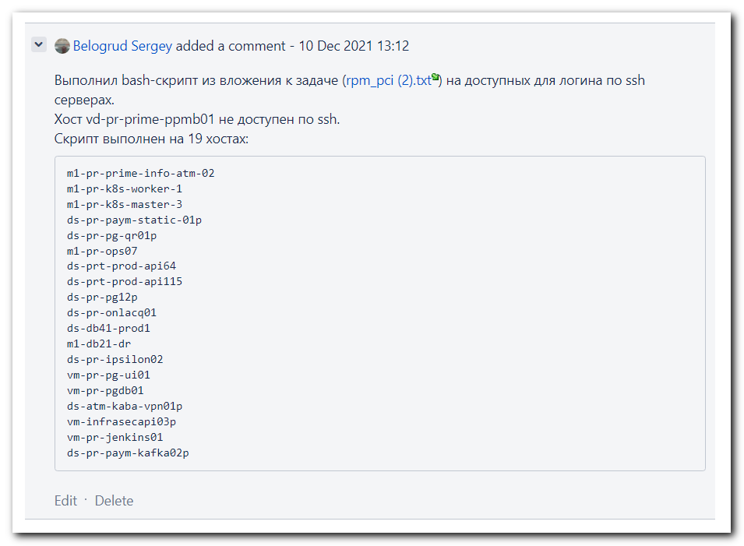

[support@nb2339]# list_of_hosts="" ; while read var1_hosts ; do list_of_hosts="${list_of_hosts} ${var1_hosts}" ; done <<
'EOF' ; for var1_hosts in ${list_of_hosts} ; do SSHPASS="$(pass common/linux-unix-ansible)" sshpass -e scp -oStrictHost
KeyChecking=no -oPubkeyAuthentication=no -oUserKnownHostsFile=/dev/null unix-ansible@${var1_hosts}:/tmp/*2021.txt /mnt/c
/data/share/ ; done
> m1-pr-prime-info-atm-02
> m1-pr-k8s-worker-1
> m1-pr-k8s-master-3
> ds-pr-paym-static-01p
> ds-pr-pg-qr01p
> m1-pr-ops07
> ds-prt-prod-api64
> ds-prt-prod-api115
> ds-pr-pg12p
> ds-pr-onlacq01
> ds-db41-prod1
> m1-db21-dr
> ds-pr-ipsilon02
> vm-pr-pg-ui01
> vm-pr-pgdb01
> ds-atm-kaba-vpn01p
> vm-infrasecapi03p
> vm-pr-jenkins01
> ds-pr-paym-kafka02p
> EOF
Warning: Permanently added 'm1-pr-prime-info-atm-02,10.212.10.23' (ECDSA) to the list of known hosts.
Warning: Permanently added 'm1-pr-k8s-worker-1,10.216.78.63' (ECDSA) to the list of known hosts.
Warning: Permanently added 'm1-pr-k8s-master-3,10.216.78.62' (ECDSA) to the list of known hosts.
Warning: Permanently added 'ds-pr-paym-static-01p,10.216.79.53' (ECDSA) to the list of known hosts.
Warning: Permanently added 'ds-pr-pg-qr01p,10.217.11.227' (ECDSA) to the list of known hosts.
Warning: Permanently added 'm1-pr-ops07,10.212.10.182' (ECDSA) to the list of known hosts.
Warning: Permanently added 'ds-prt-prod-api64,10.213.18.104' (ED25519) to the list of known hosts.
Warning: Permanently added 'ds-prt-prod-api115,10.213.192.92' (ECDSA) to the list of known hosts.
Warning: Permanently added 'ds-pr-pg12p,10.213.8.106' (ECDSA) to the list of known hosts.
Warning: Permanently added 'ds-pr-onlacq01,10.217.11.7' (RSA) to the list of known hosts.
scp: /tmp/ds-pr-onlacq01.2021.txt: Permission denied
Warning: Permanently added 'ds-db41-prod1,10.219.47.144' (ECDSA) to the list of known hosts.
Warning: Permanently added 'm1-db21-dr,10.217.127.82' (ECDSA) to the list of known hosts.
scp: /tmp/m1-db21-dr.2021.txt: Permission denied
Warning: Permanently added 'ds-pr-ipsilon02,10.219.49.32' (ECDSA) to the list of known hosts.
Warning: Permanently added 'vm-pr-pg-ui01,10.217.12.88' (ECDSA) to the list of known hosts.
Warning: Permanently added 'vm-pr-pgdb01,10.217.12.80' (RSA) to the list of known hosts.
Warning: Permanently added 'ds-atm-kaba-vpn01p,10.219.29.3' (ECDSA) to the list of known hosts.
Warning: Permanently added 'vm-infrasecapi03p,10.216.76.11' (ECDSA) to the list of known hosts.
Warning: Permanently added 'vm-pr-jenkins01,10.216.77.1' (ECDSA) to the list of known hosts.
Warning: Permanently added 'ds-pr-paym-kafka02p,10.217.9.18' (ECDSA) to the list of known hosts.
[support@nb2339]#

[support@nb2339]# list_of_hosts="" ; while read var1_hosts ; do list_of_hosts="${list_of_hosts} ${var1_hosts}" ; done << 'EOF' ; for var1_hosts in ${list_of_hosts} ; do SSHPASS="$(pass common/linux-root)" sshpass -e scp -oStrictHostKeyChecking=no -oPubkeyAuthentication=no -oUserKnownHostsFile=/dev/null root@${var1_hosts}:/tmp/*2021.txt /mnt/c/data/share/ ; done
> ds-pr-onlacq01
> m1-db21-dr
> EOF
Warning: Permanently added 'ds-pr-onlacq01,10.217.11.7' (RSA) to the list of known hosts.
Warning: Permanently added 'm1-db21-dr,10.217.127.82' (ECDSA) to the list of known hosts.
Permission denied, please try again.
[support@nb2339]#

[support@nb2339]# list_of_hosts="" ; while read var1_hosts ; do list_of_hosts="${list_of_hosts} ${var1_hosts}" ; done <<
'EOF' ; for var1_hosts in ${list_of_hosts} ; do SSHPASS="$(pass common/linux-freeipa)" sshpass -e scp -oStrictHostKeyCh
ecking=no -oPubkeyAuthentication=no -oUserKnownHostsFile=/dev/null s_s.belogrud@${var1_hosts}:/tmp/*2021.txt /mnt/c/data
/share/ ; done
> m1-db21-dr
> EOF
Warning: Permanently added 'm1-db21-dr,10.217.127.82' (ECDSA) to the list of known hosts.
scp: /tmp/m1-db21-dr.2021.txt: Permission denied
[support@nb2339]#

[s.belogrud@nb2339]# ssh s_s.belogrud@m1-db21-dr
Last login: Fri Dec 10 12:15:05 2021 from nb2339.tcsbank.ru
[s_s.belogrud@m1-db21-dr ~]$ ls -Alh /tmp/*2021.txt
-rw------- 1 root root 529K Dec 10 12:52 /tmp/m1-db21-dr.2021.txt
[s_s.belogrud@m1-db21-dr ~]$
[s_s.belogrud@m1-db21-dr ~]$ sudo -i
[sudo] password for s_s.belogrud:
[18:07:47 root@m1-db21-dr ~]# chmod o+r /tmp/m1-db21-dr.2021.txt
[18:07:55 root@m1-db21-dr ~]# ls -Alh /tmp/m1-db21-dr.2021.txt
-rw----r-- 1 root root 529K Dec 10 12:52 /tmp/m1-db21-dr.2021.txt
[18:08:00 root@m1-db21-dr ~]#

[support@nb2339]# list_of_hosts="" ; while read var1_hosts ; do list_of_hosts="${list_of_hosts} ${var1_hosts}" ; done << 'EOF' ; for var1_hosts in ${list_of_hosts} ; do SSHPASS="$(pass common/linux-freeipa)" sshpass -e scp -oStrictHostKeyChecking=no -oPubkeyAuthentication=no -oUserKnownHostsFile=/dev/null s_s.belogrud@${var1_hosts}:/tmp/*2021.txt /mnt/c/data/share/ ; done
> m1-db21-dr
> EOF
Warning: Permanently added 'm1-db21-dr,10.217.127.82' (ECDSA) to the list of known hosts.
[support@nb2339]#

[18:08:00 root@m1-db21-dr ~]# chmod o-r /tmp/m1-db21-dr.2021.txt
[18:09:25 root@m1-db21-dr ~]# ls -Alh /tmp/m1-db21-dr.2021.txt
-rw------- 1 root root 529K Dec 10 12:52 /tmp/m1-db21-dr.2021.txt
[18:09:27 root@m1-db21-dr ~]# logout
[s_s.belogrud@m1-db21-dr ~]$ logout
Connection to m1-db21-dr closed.
[s.belogrud@nb2339]#

[support@nb2339]# cd /mnt/c/data/share/
[support@nb2339]# tar cvzf 20211210-1817.in-1795.tgz *2021.txt
ds-atm-kaba-vpn01p.tcsbank.ru.2021.txt
ds-db41-prod1.tcsbank.ru.2021.txt
ds-pr-ipsilon02.2021.txt
ds-pr-onlacq01.2021.txt
ds-pr-paym-kafka02p.tcsbank.ru.2021.txt
ds-pr-paym-static-01p.tcsbank.ru.2021.txt
ds-pr-pg-qr01p.tcsbank.ru.2021.txt
ds-pr-pg12p.tcsbank.ru.2021.txt
ds-prt-prod-api115.tcsbank.ru.2021.txt
ds-prt-prod-api64.tcsbank.ru.2021.txt
m1-db21-dr.2021.txt
m1-pr-k8s-master-3.tcsbank.ru.2021.txt
m1-pr-k8s-worker-1.tcsbank.ru.2021.txt
m1-pr-ops07.tcsbank.ru.2021.txt
m1-pr-prime-info-atm-02.tcsbank.ru.2021.txt
vm-infrasecapi03p.tcsbank.ru.2021.txt
vm-pr-jenkins01.tcsbank.ru.2021.txt
vm-pr-pg-ui01.tcsbank.ru.2021.txt
vm-pr-pgdb01.tcsbank.ru.2021.txt
[support@nb2339]# cd -
/home/support/work/20211210-1747
[support@nb2339]#

# I created ansible-role for this task.
#
[support@nb2339]# export ANSIBLE_CONFIG=ansible.cfg ; logfile="$(date +%Y%m%d-%H%M).playbook.log.txt" ; ansible-playbook 20211210-1857.rpm_pci.yml -i list_of_hosts --become --extra-vars "ansible_user=unix-ansible ansible_password=$(pass common/linux-unix-ansible) ansible_sudo_pass=$(pass common/linux-unix-ansible) ansible_ssh_common_args='-oStrictHostKeyChecking=no -oPubkeyAuthentication=no -oUserKnownHostsFile=/dev/null'" -f 10 | tee -a ./output/${logfile}

Dec 13, 2021 I published this role to our git repository: 20211213 vm-gitlab01 - repository rpm_pci

